Chhaya Patel, ET 156,

Professor Badrinath Mirmira, East West University

**Lab 7 Full wave Rectifier**

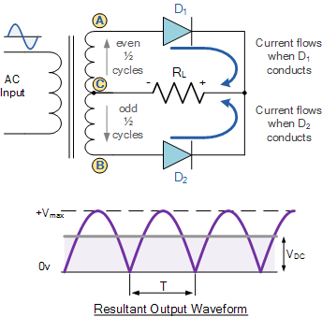

**Take-Home Messages**

* How can make Fullwave rectification?
* What is Diode functioning?

**Lab 7 Full wave Rectifier**

Chhaya Patel, ET 156,

Professor Badrinath Mirmira, East West University

A Diode is a Semiconductor device, rectify current and convert AC to DC with rectification process. Diode biased conducts current only in the forward region only. Diode block the current in reverse directions. Diode always passes current in one direction only. It is also called forward biased activated Diode. Flow of electron passes through Positive to Positive and Blocked the current on Electron flow Positive to Negative.

INTRODUCTION[1]

A rectifier is an electrical device that [converts](https://en.wikipedia.org/wiki/Electric_power_conversion) [alternating current](https://en.wikipedia.org/wiki/Alternating_current) (AC), which periodically reverses direction, to [direct current](https://en.wikipedia.org/wiki/Direct_current) (DC), which flows in only one direction. The process is known as rectification, since it "straightens" the direction of current. Physically, rectifiers take a number of forms, including [vacuum tube](https://en.wikipedia.org/wiki/Vacuum_tube) [diodes](https://en.wikipedia.org/wiki/Diode), [mercury-arc valves](https://en.wikipedia.org/wiki/Mercury-arc_valve), stacks of copper and selenium oxide plates, [semiconductor diodes](https://en.wikipedia.org/wiki/Semiconductor_diode), [silicon-controlled rectifiers](https://en.wikipedia.org/wiki/Silicon-controlled_rectifier) and other silicon-based semiconductor switches. Historically, even synchronous electromechanical switches and motors have been used. Early radio receivers, called [crystal radios](https://en.wikipedia.org/wiki/Crystal_radio), used a "[cat's whisker](https://en.wikipedia.org/wiki/Cat%27s-whisker_detector)" of fine wire pressing on a crystal of [galena](https://en.wikipedia.org/wiki/Galena) (lead sulfide) to serve as a point-contact rectifier or "crystal detector".

By applying a negative voltage (reverse bias) results in the free charges being pulled away from the junction resulting in the depletion layer width being increased. This has the effect of increasing or decreasing the effective resistance of the junction itself allowing or blocking current flow through the diode.

  A. Equipment’s required:

Equipment

1. Digital Multimeter Model - M9803R

2. Alligator Clips.

3. Breadboard.

4. Oscilloscope.

5. Multisim Module (Software) 14.0 Ver.

6. Data Sheets of Diode IN4001.

## Components

## 1. Resistor 6.8KΩ - 01

## 2. Transistor IN4001 - 02

## 3. Transformer CT rated - 01

## Procedure

Build Schematic Design Circuit on Multisim Software Ver 14.1.

Build Circuit on Breadboard and connect all components as shown in Schematic Design map with help of wires.

Connect two Diode through Trasnsformer IN4001 and Resistors 6.8 K as per schematic design.

Designed circuit as per multisim schematic design to connect all component.

Do the continuity Check of the circuit with help of Digital Multimeter.

Obtain Approval from Professor / Lab instructor to do Power Supply 'ON'.

Connect Oscilloscope to the RL and find Full wave Sine wave.

Switch off the power supply.

**Design Schematic of Circuit on Multisim**

Before build circuit on breadboard, It is necessary to designed Circuit on Multisim Ver 14.1, It helps to better understand the circuit. With Multisim can study and analytically trace the circuit and get accurate reading before build the circuit. After designed four schematic Circuits on Multisim 14.1.



**Figure 3 : Schematic Design**

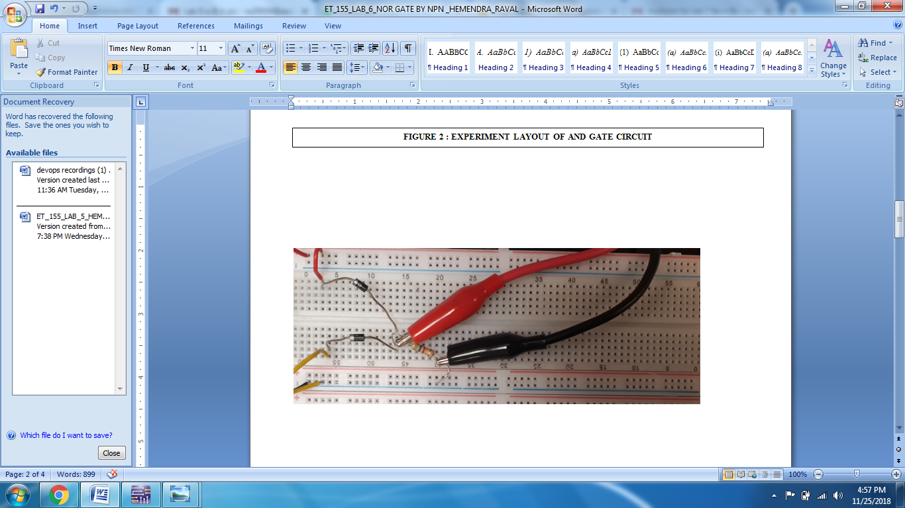

# **figure 4 : breadboard circuit**

fullwave rectifier circuit consists of two power diodes connected to a single load resistance (RL) with each diode taking it in turn to supply current to the load. When point A of the transformer is positive with respect to point C, diode D1 conducts in the forward direction as indicated by the arrows. When point B is positive (in the negative half of the cycle) with respect to point C, diode D2 conducts in the forward direction and the current flowing through resistor R is in the same direction for both half-cycles. As the output voltage across the resistor R is the phasor sum of the two waveforms combined, this type of full wave rectifier circuit is also known as a “bi-phase” circuit.

# **CONCLUSION**

During the fullwave rectifier laboratory experiment it was found the Silicon diode in series circuit convert AC to DC and it was proven at Oscilloscope wave shown fullwave.

**References**

1. Multisim Schematic Design Ver 14.1
2. Handout of ET_156 Digital System.
3. https://www.electronics-tutorials.ws/diode
4. Class Notes.

1. This experiment was carried out with Lab Partner R Singh Student East West in part by East West University, Electronic Engineering Department, 816 Michigan Avenue, Chicago, IL 60605. Chhaya Patel (pa20622@eastwest.edu) is with the department of electric engineering at East West University, Chicago, IL 60605.